

|  |
| --- |
| THE TECH GIANTS  2018 |
| Submitted in partial fulfillment of the  Requirements for the award of  Degree of Bachelor of Technology in Computer Science & Engineering |
| cSG41/CSE24(A)  Made by:  Shreyans Jain 18BCS3465  Shivam Singh 18BCS3463 |

# The Tech Giants

This page collaborates with university students who are passionate about growing developer communities and supports them with starting student clubs on their campuses. This page gives the way to young developers and students who want to learn more about new technologies and innovations.

These pages provide students with the opportunity to:

* Grow their knowledge on developer technologies and more through peer to peer workshops and events.
* Gain relevant industry experience by solving problems for local organizations with technology based solutions.
* Showcase their prototypes and solutions to their local community and industry leaders.

This page connects developers to different websites of multi-national companies like google, apple, Facebook.

“83% of the DSC Leads in India shared that they acquired a job or internship due to their experience in DSC”

*Based on DSC India exit survey 2017-2018

Developing for different platforms puts the cutting-edge technology at your fingertips, giving you limitless ways to bring incredible apps to users around the world. These powerful platforms each offer unique capabilities and user experiences, yet integrate tightly to form a true ecosystem. Hardware, software, and services are designed from the ground up to work together so you can build intuitive, multi-faceted experiences that are genuinely seamless.

# Tools and Technology used

In the world of software development, what’s built falls into two categories: everything that’s seen by the user and the processes happening in the background. What we see and interact with as the visitors of a website, or as the end user of a mobile app, is considered front-end technology. All the behind-the-scenes activity that delivers the data and the speed with which that data is delivered falls into backend technology.

The open nature of the World Wide Web presents incredible opportunities for people who want to create websites or online applications. To take full advantage of the web's capabilities, you need to know how to use them.

The front end stack is made up of many different languages and libraries. While these vary from application to application, there are only a few generic languages understood by all web browsers. These three main front-end coding languages are HTML, CSS and JavaScript. Together, they create the underlying scaffolding that web browsers use to render the web pages that we interact with every day.

Web technologies

* HTML

Hyper Text Markup Language (HTML) is used to describe and define the *content* of a webpage.

* CSS

Cascading Style Sheets (CSS) are used to describe the *appearance or presentation* of content on a webpage.

Scripting

* JAVASCRIPT

JavaScript is the programming language that runs in your browser. You can use it to add interactivity and other dynamic features to your website or application.

HTML CODE:-

|  |  |
| --- | --- |
|  | <html> |
|  | <head> |
|  | <title>Shreyans creations</title> |
|  | <link rel="stylesheet" type="text/css" href="mastercss.css"> |
|  | </head> |
|  | <body> |
|  | <div> |
|  | <header> |
|  |  |
|  | <div class=main> |
|  |  |
|  | <div class=logo> |
|  | <h1>The Tech Giants</h1> |
|  | </div> |
|  |  |
|  | <ul> |
|  | <li class=active><a href="">Home</a></li> |
|  | <li><a href="<https://developers.google.com/>">Google</a></li> |
|  | <li><a href="<https://developer.apple.com/>">Apple</a></li> |
|  | <li><a href="<https://developers.facebook.com/>">Facebook</a></li> |
|  | <li><a href="superform.html">Join us</a></li> |
|  | </ul> |
|  | </div> |
|  | <div class="title"> |
|  | <h1>The Tech Giants</h1> |
|  | </div> |
|  |  |
|  | <div class="button"> |
|  | <a href="superform.html" class="btn">Join us</a> |
|  | </div> |
|  |  |
|  |  |
|  | </header> |
|  | </div> |
|  |  |
|  | <div class="two"> |
|  | <div class=window> |
|  |  |
|  |  |
|  |  |
|  | <div ><img src="googlelogo.jpg"></div> |
|  |  |
|  | <div class=box1> |
|  | <img src="dsc.jpg" class=dsc> |
|  | <h2 style="color:#1E90FF;">Developer Student`s Club</h2> |
|  | <p>Developer Student Clubs train thousands of student developers globally |
|  | and work with their communities to solve real-life problems. |
|  | Check out some of our stories to learn more.</p> |
|  | <a href="<https://developers.google.com/programs/dsc/>"><input type=submit value="Learn More"></a> |
|  | </div> |
|  |  |
|  |  |
|  |  |
|  | <div class=box2> |
|  | <img src="wt.jpg" class=wt> |
|  | <h2>Women Techmakers</h2> |
|  | <p>Google's Women Techmakers program provides visibility, community, |
|  | and resources for women in technology.Women Techmakers is continually |
|  | launching global scalable initiatives and piloting new programs to support and empower women in the industry.</p> |
|  | <a href="<https://www.womentechmakers.com/>"><input type=submit value="Learn More"></a> |
|  | </div> |
|  |  |
|  |  |
|  |  |
|  | <div class=box3> |
|  | <img src="launchpad.jpg" class=launchpad> |
|  | <h2>Launchpad</h2> |
|  | <p>A global acceleration program that helps startups build and scale |
|  | great products by matching them with the best of Google - its people, network, |
|  | and advanced technologies.</p> |
|  | <a href="<https://developers.google.com/programs/launchpad/>"><input type=submit value="Learn More"></a> |
|  | </div> |
|  |  |
|  | </div> |
|  |  |
|  | </div> |
|  | </div> |
|  |  |
|  | </div> |
|  |  |
|  | <div class="three"> |
|  |  |
|  | <div class="back"> |
|  | <img src="applelogo.jpg"> |
|  |  |
|  |  |
|  | <div class="content"> |
|  |  |
|  | <h1>From Code to Customer</h1> |
|  | <p align="center">Join the Apple Developer Program to reach customers around the world on the App Store for iPhone, iPad, |
|  | Mac, Apple Watch, Apple TV, and iMessage, and on the Safari Extensions Gallery. You’ll also get access to |
|  | beta software, advanced app capabilities, extensive beta testing tools, and app analytics.</p> |
|  | <div class="click"> |
|  | <a href="<https://developer.apple.com/programs/>" class="abc">Join us</a> |
|  | </div> |
|  | </div> |
|  | </div> |
|  |  |
|  | </div> |
|  |  |
|  | <div class="four"> |
|  |  |
|  |  |
|  | <div class=window2> |
|  |  |
|  |  |
|  |  |
|  | <div class="title2"><img src="fblogo.jpg"></div> |
|  |  |
|  | <div class=box4> |
|  | <img src="fbdc.jpeg" class=fbdc> |
|  | <h2 style="color:black;">Developer Circles</h2> |
|  | <p>Attend local meetups, collaborate in Facebook Groups and learn about the latest Facebook technologies. |
|  | Whatever you build, Developer Circles connects you to collaborate, learn, and code with other local developers. |
|  | </p> |
|  | <a href="<https://developers.facebook.com/developercircles>"><input type=submit value="Learn More"></a> |
|  | </div> |
|  |  |
|  |  |
|  |  |
|  | <div class=box5> |
|  | <img src="f8.jpg" class=ff> |
|  | <h2>F8</h2> |
|  | <p>A conversation about |
|  | technology and |
|  | human connection. |
|  | That's a wrap for F8 2019<br> |
|  | 2019 marked Facebook's 10th F8. What started as an 8-hour hackathon has evolved into a 2-day event for developers, creators, |
|  | entrepreneurs and innovators from around the world.</p> |
|  | <a href="<https://www.f8.com/?fbclid=IwAR2tZlT1I0iQeEky2aVurhCvRLBcw-hYw9LOBvWkZOmNQ5U1Gr6XJehZ4bw>"><input type=submit value="Learn More"></a> |
|  | </div> |
|  |  |
|  |  |
|  |  |
|  | <div class=box6> |
|  | <img src="fbstart.jpeg" class=fbstart> |
|  | <h2 style="color:black;">FbStart</h2> |
|  | <p>FbStart provides year-round technical support from Facebook, an exclusive community of global startups, free credits to tools and services from dozens of premier partners, |
|  | training on Facebook Developer Tools, and more</p> |
|  | <a href="<https://developers.facebook.com/fbstart>"><input type=submit value="Learn More"></a> |
|  | </div> |
|  |  |
|  | </div> |
|  |  |
|  | </div> |
|  | </div> |
|  |  |
|  |  |
|  | </div> |
|  | </body> </html> |

CSS CODE

header{

background-image:linear-gradient(rgba(0,0,0,0.5),rgba(0,0,0,0.5)), url(mbg.jpg);

height:100vh;

background-size: cover;

background-position: center;

}

ul{

float: right;

list-style-type: none;

margin-top:25px;

}

ul li{

display: inline-block;

}

ul li a{

text-decoration:none;

color: #fff;

padding:5px 20px;

border: 1px solid transparent;

transition: 3s ease;

}

ul li a:hover{

background-color:#fff;

color:#000;

}

.logo h1{

float: left;

width:150x;

height: auto;

color: #fff;

font-size:30px;

}

.main{

max-width:1500px;

margin:auto;

}

ul li.active a{

background-color:#fff;

color:#000;

}

.title{

position: absolute;

top:50%;

left:50%;

transform: translate(-50%,-50%);

}

.title h1{

color: #fff;

font-size:70px;

}

.button{

position: absolute;

top:60%;

left:50%;

transform: translate(-50%,-50%);

}

.btn{

border: 1px solid #fff;

padding: 10px 30px;

color:#fff;

text-decoration:none;

}

.btn:hover{

background-color:#fff;

color:#000;

}

*{

margin:0;

padding:0;

font-family:Sans Serif;

}

.window{

background-image: url(googlebg.jpg);

height:100vh;

background-size: cover;

background-position: center;

}

.box1{

width: 300px;

height: 500px;

background:white;

color: #fff;

top:60%;

left:25%;

position: absolute;

transform: translate(-50%,-50%);

box-sizing:border-box;

padding:50px;

opacity:0.85;

box-shadow: 10px 10px 10px 10px grey;

}

.box2{

width: 300px;

height: 500px;

background:white;

color: #fff;

top:60%;

left:50%;

position: absolute;

transform: translate(-50%,-50%);

box-sizing:border-box;

padding:50px;

opacity:0.85;

box-shadow: 10px 10px 10px 10px grey;

}

.box3{

width: 300px;

height: 500px;

background:white;

color: #fff;

top:60%;

left:75%;

position: absolute;

transform: translate(-50%,-50%);

box-sizing:border-box;

padding:50px;

opacity:0.85;

box-shadow: 10px 10px 10px 10px grey;

}

.dsc{

position:absolute;

width:200px;

height: auto;

}

.wt{

position:absolute;

width:200px;

height: auto;

}

.launchpad{

position:absolute;

width:200px;

height: auto;

}

h2{

margin:0;

padding: 0 0 0px;

font-size:23px;

position:absolute;

top:225px;

left:20px;

}

.box2 h2{

margin:0;

padding: 0 0 0px;

font-size:23px;

position:absolute;

top:225px;

left:50px;

color:black;

}

.box3 h2{

margin:0;

padding: 0 0 0px;

font-size:23px;

position:absolute;

top:225px;

left:95px;

color:red;

}

p{

margin:0;

padding: 0 0 0px;

font-size:18px;

position:absolute;

top:250px;

left:15px;

right:15px;

color:black;

text-align:justify;

}

.box1 a,.box2 a,.box3 a{

position:absolute;

top:450px;

left:15px;

right:15px;

}

.box1 input[type="submit"],.box2 input[type="submit"],.box3 input[type="submit"]

{

border:none;

outline: none;

height:20px;

font-size:18px;

background:red;

color:white;

width:270px;

}

.box1 input[type="submit"]:hover,.box2 input[type="submit"]:hover,.box3 input[type="submit"]:hover

{

cursor:pointer;

background:#ffc107;

color:#000;

}

div.two{

position:relative;

}

div.three{

position:relative;

}

div.four{

position:relative;

}

.back{

background:black;

height:60vh;

background-size:cover;

background-position: center;

}

.content{

position: absolute;

left:50%;

transform: translate(-50%,-50%);

}

.image{

position:relative;

left:10%;

}

.content h1{

position:relative;

left:50%;

color: #fff;

font-size:70px;

transform: translate(-50%,-50%);

}

.content p{

color: #fff;

top:60%;

font-size:25px;

}

.click{

position: absolute;

top:300%;

left:50%;

transform: translate(-50%,-50%);

}

.abc{

border: 1px solid #fff;

padding: 10px 30px;

color:#fff;

text-decoration:none;

}

.abc:hover{

background-color:#fff;

color:#000;

}

.window2{

background-image: url(fbbg.jpg);

height:100vh;

background-size: cover;

background-position: center;

}

.box4{

width: 300px;

height: 500px;

background:white;

color: #fff;

top:60%;

left:25%;

position: absolute;

transform: translate(-50%,-50%);

box-sizing:border-box;

padding:50px;

opacity:0.85;

box-shadow: 10px 10px 10px 10px lightskyblue;

}

.box5{

width: 300px;

height: 500px;

background:white;

color: #fff;

top:60%;

left:50%;

position: absolute;

transform: translate(-50%,-50%);

box-sizing:border-box;

padding:50px;

opacity:0.85;

box-shadow: 10px 10px 10px 10px lightskyblue;

}

.box6{

width: 300px;

height: 500px;

background:white;

color: #fff;

top:60%;

left:75%;

position: absolute;

transform: translate(-50%,-50%);

box-sizing:border-box;

padding:50px;

opacity:0.85;

box-shadow: 10px 10px 10px 10px lightskyblue;

}

.fbdc{

position:absolute;

width:200px;

height: auto;

}

.ff{

position:absolute;

width:200px;

height: auto;

}

.fbstart{

position:absolute;

width:200px;

height: auto;

}

.box4 h2{

margin:0;

padding: 0 0 0px;

font-size:23px;

position:absolute;

top:225px;

left:65px;

}

.box5 h2{

margin:0;

padding: 0 0 0px;

font-size:23px;

position:absolute;

top:225px;

left:130px;

color:black;

}

.box6 h2{

margin:0;

padding: 0 0 0px;

font-size:23px;

position:absolute;

top:225px;

left:110px;

color:red;

}

.box6 p,.box5 p,.box4 p{

margin:0;

padding: 0 0 0px;

font-size:18px;

position:absolute;

top:250px;

left:15px;

right:15px;

color:black;

text-align:justify;

}

.box4 a,.box5 a,.box6 a{

position:absolute;

top:450px;

left:15px;

right:15px;

}

.box4 input[type="submit"],.box5 input[type="submit"],.box6 input[type="submit"]

{

border:none;

outline: none;

height:20px;

font-size:18px;

background:red;

color:white;

width:270px;

}

.box4 input[type="submit"]:hover,.box5 input[type="submit"]:hover,.box6 input[type="submit"]:hover

{

cursor:pointer;

background:#ffc107;

color:#000;

}

SNAPSHOTS

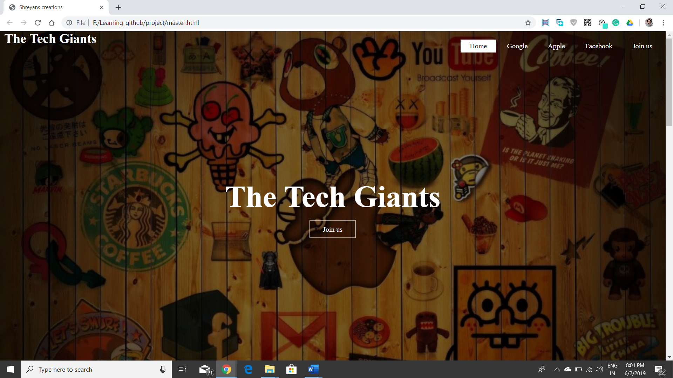

* Homepage-This is the homepage of our website. “THE TECH GIANTS” .This page is connected to various developing companies which provides different kinds of services to the young student and developer. The page also has a join button on the center which take the user to the sign up page of the website.

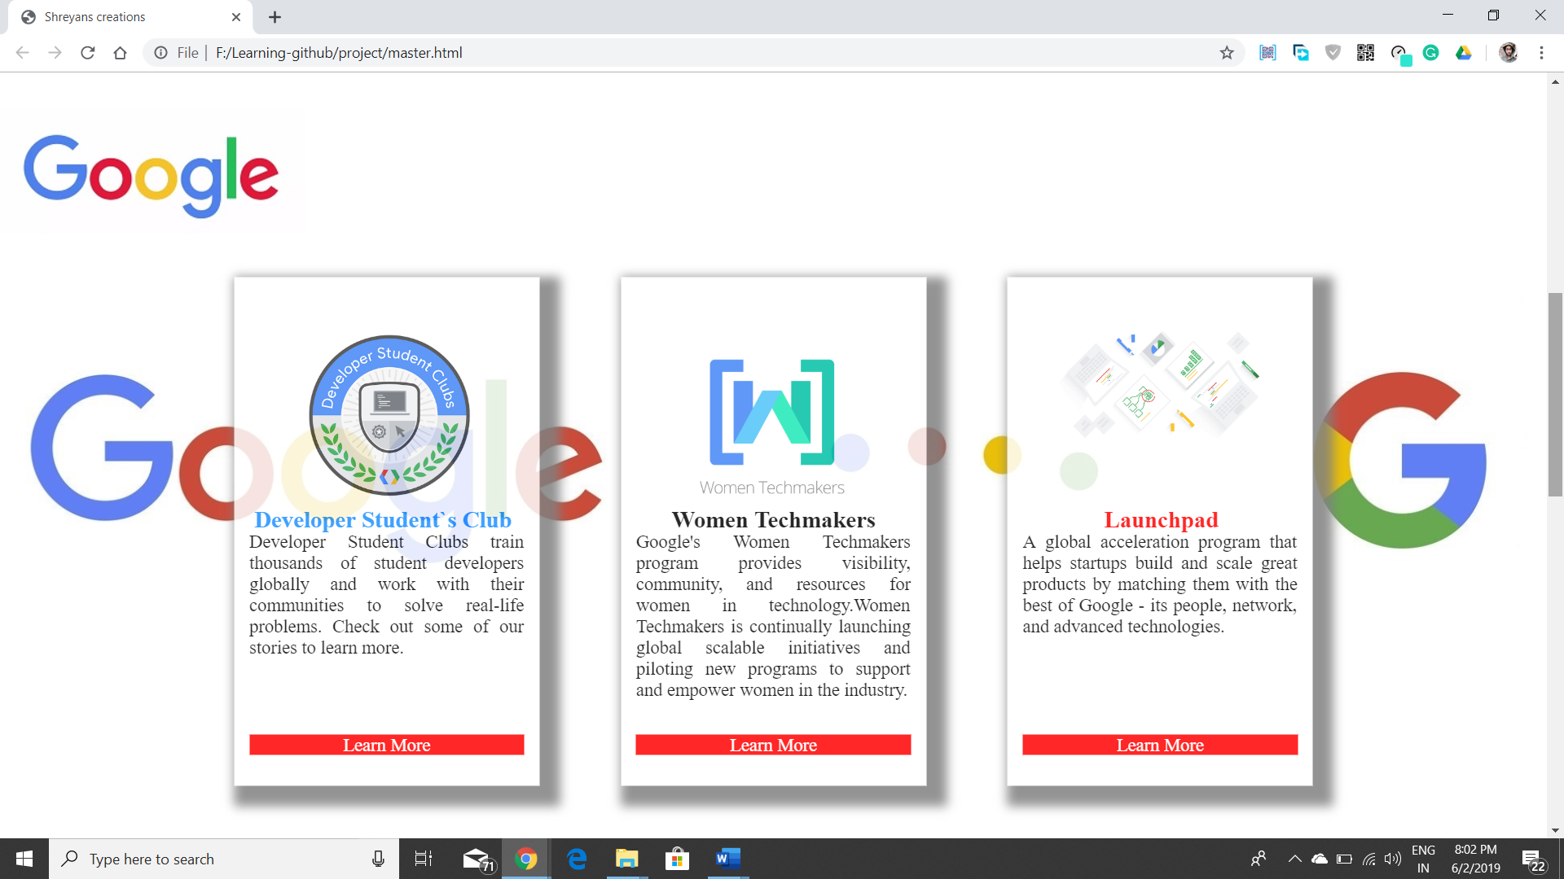

* Goggle-This is the second part of the webpage where it shows different programs organized by google. These programs provide solution to lot of problems faced by the young generation of developers and the developing community. It is connected to different developer programs and has few color changing effects in the learn more button.

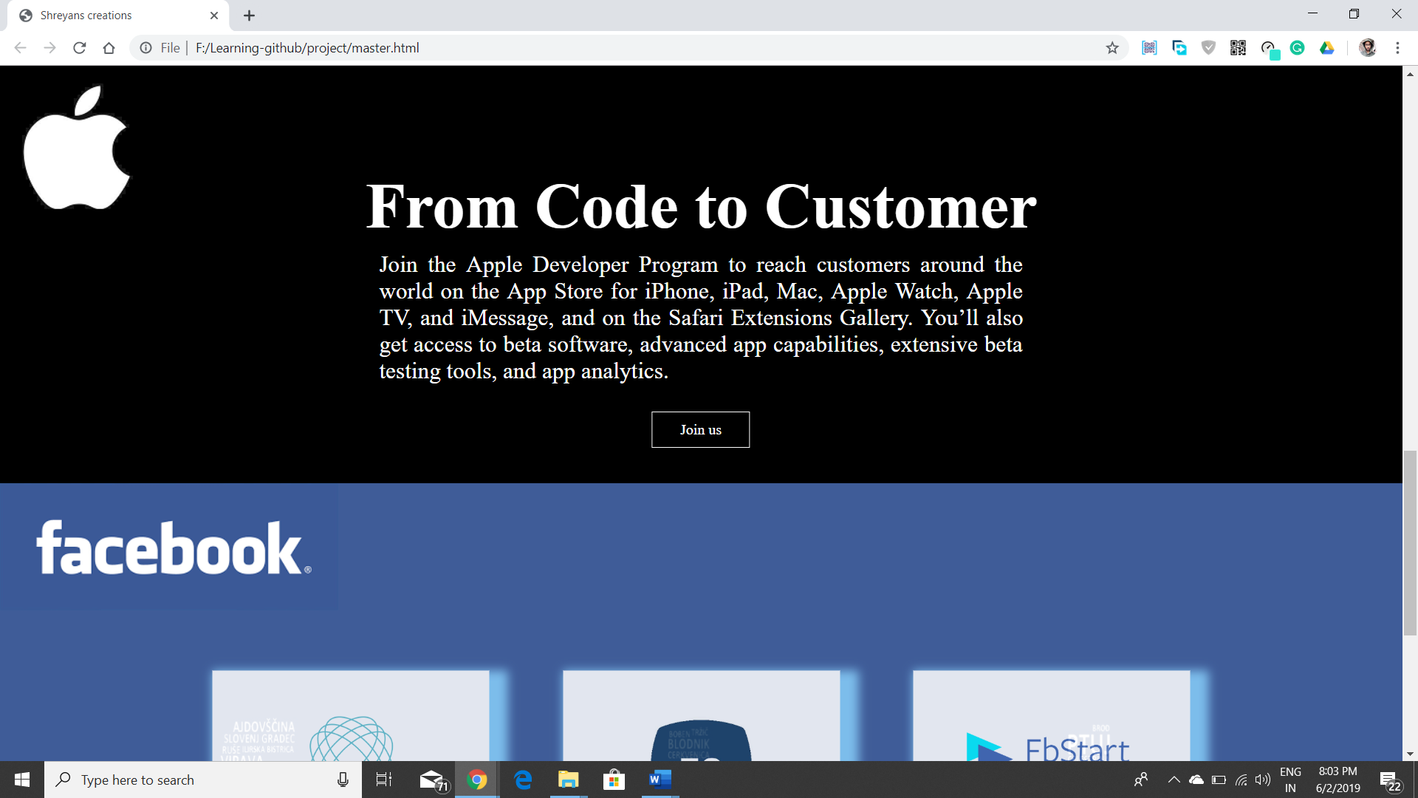

* Apple-This is the third part of the homepage which connects us to the apple`s developing community. Even though it is focuses largely on IOS Development it has a large developing community. It provides beta software, advanced app capabilities, extensive beta testing tools, and app analytics. It shows the customer’s relationship to a developer.

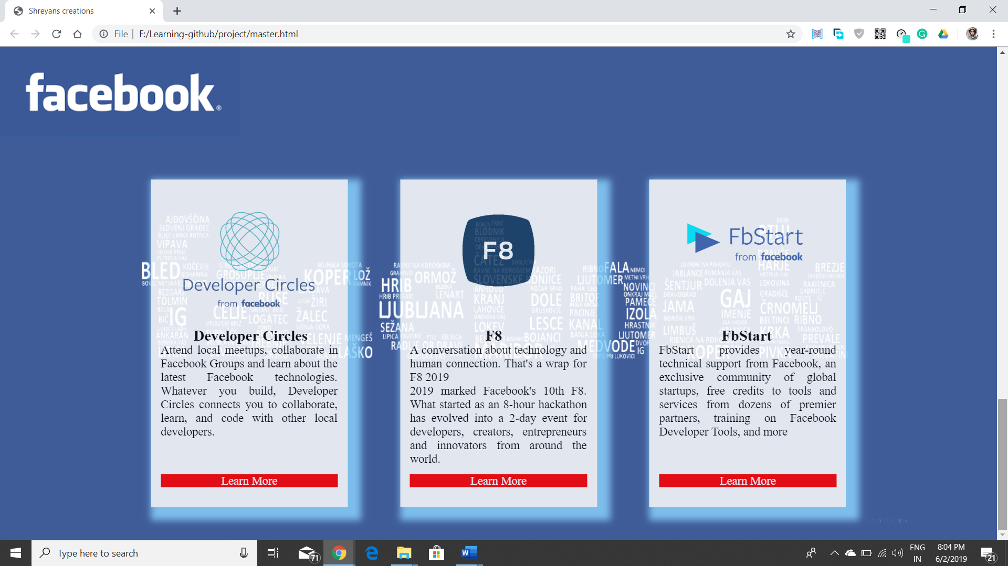

* Facebook-This is the last part of the homepage which shows different platforms and programs provided by Facebook. It also tells about the Facebook`s largest event(F8) for developers, creators, entrepreneurs, and innovators around the world.

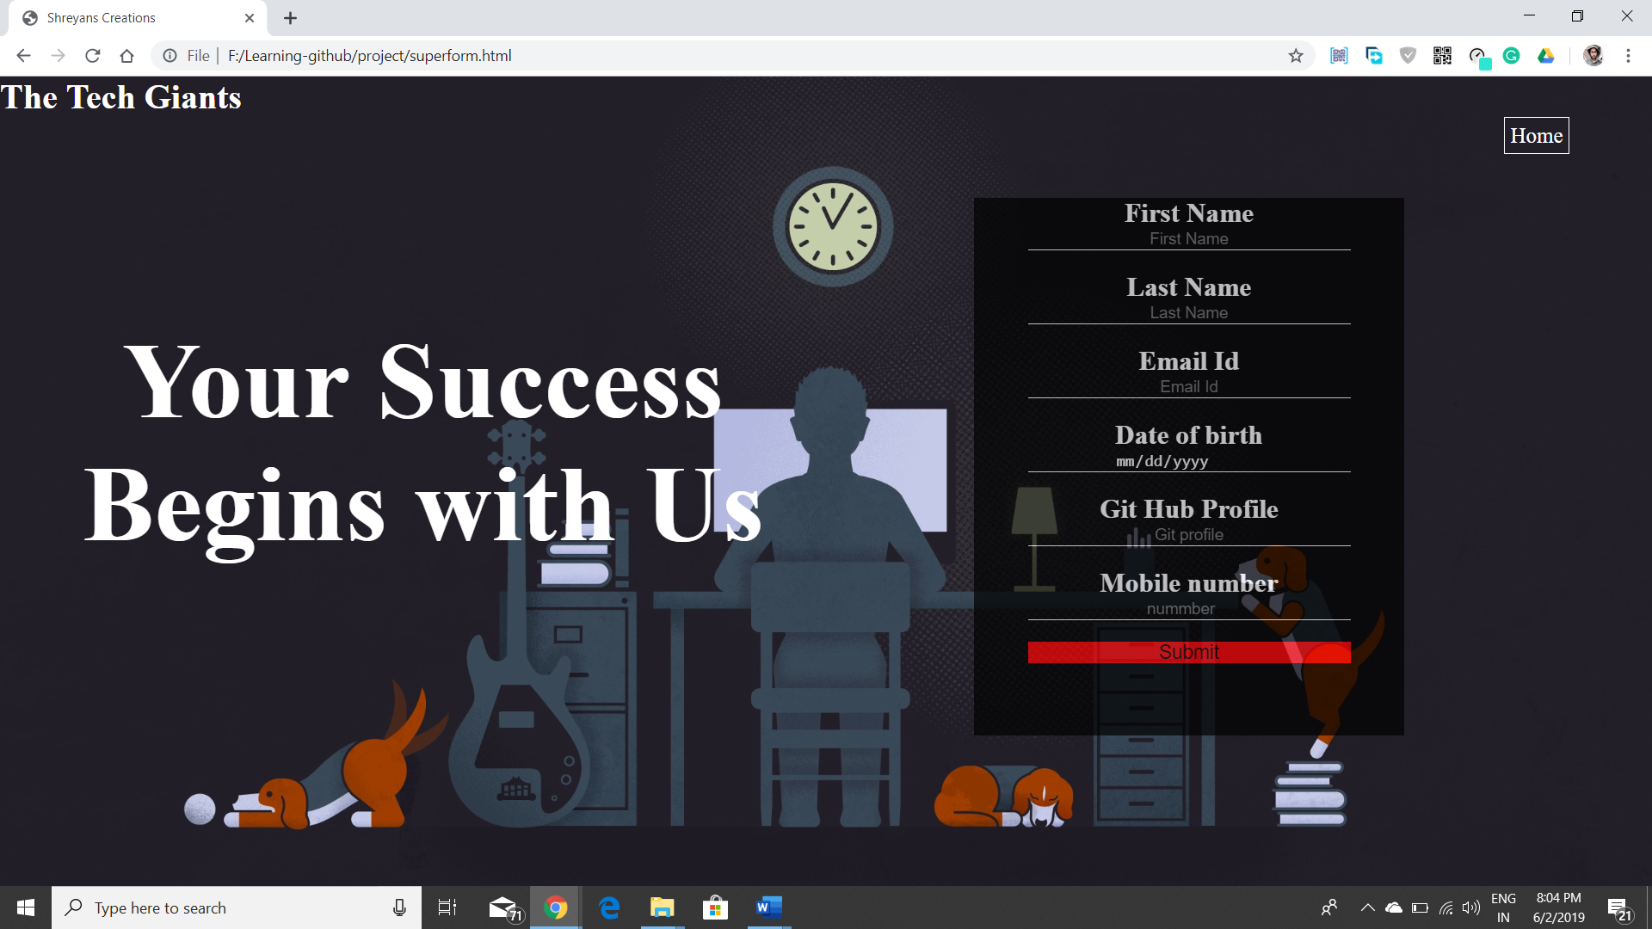

* Login page- This is the sign-up page of our website which takes basic information from users and provide latest news about technology, about conferences like GOOGLE IO and much more. It is also connected to home page in case a user needs to go back to the home page.

“Your success begins with us”

CONCLUSION

It’s helpful to understand these types of front-end interactions. Why? Because the next time you look at a developer’s online profile, you can make an informed guess on what was built using JavaScript and ask the developer, “I see a lot of powerful user interactions here. Did you build those using JavaScript?”

This demonstrates credibility as it communicates that you understand how the web works, recognize the abilities of a candidate, and aren’t making an assumption that a candidate may have to correct and educate you on later. It starts a conversation around what technologies a front-end engineer is excited about and used on that project.

REFRENCES

* [https://developers.google.com](https://developers.google.com/)
* [https://developer.apple.com](https://developer.apple.com/)
* [https://developers.facebook.com](https://developers.facebook.com/)
* [www.recruitinginnovation.com/blog/front-end-technologies/](http://www.recruitinginnovation.com/blog/front-end-technologies/)
* [www.google.com/search?q=font+end+technologies&oq=font+end+technologies&aqs=chrome..69i57.6646j0j3&sourceid=chrome&ie=UTF-8](http://www.google.com/search?q=font+end+technologies&oq=font+end+technologies&aqs=chrome..69i57.6646j0j3&sourceid=chrome&ie=UTF-8)